1)Create a ClusterIP service for an Apache web server pod.

Step 1: Understand What You're Doing
- Pod → Runs Apache (httpd)
- Service (ClusterIP) → Exposes the pod inside Kubernetes cluster only
ClusterIP = Internal communication (not accessible from browser outside cluster)

Step 2: Create Apache Pod (YAML)
Create a file:
vi apache-pod.yaml

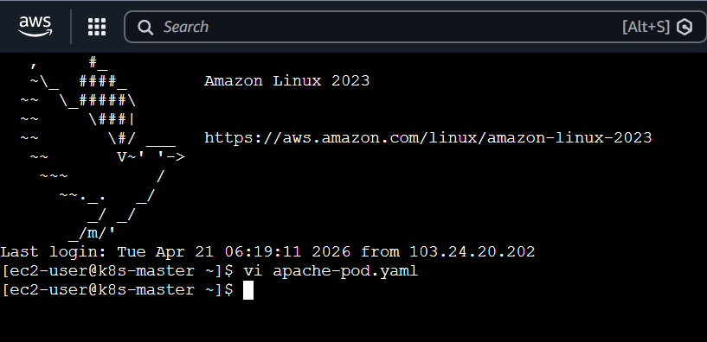

Paste this:
apiVersion: v1
kind: Pod
metadata:
name: apache-pod
labels:
app: apache
spec:
containers:
- name: apache-container
image: httpd
ports:
- containerPort: 80

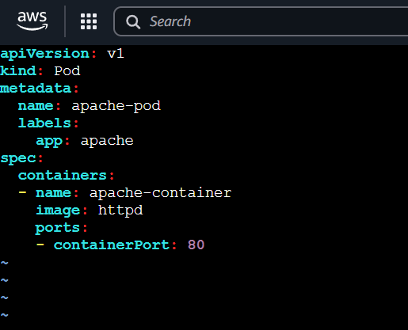

Step 3: Apply the Pod
kubectl apply -f apache-pod.yaml

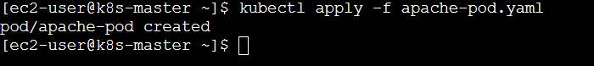
Check:
kubectl get pods -o wide

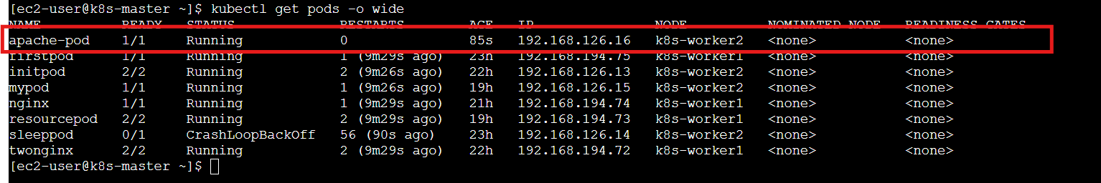
Wait until STATUS = Running

Step 4: Verify Apache is Working
kubectl exec -it apache-pod -- curl localhost
OR
kubectl run test-pod --image=busybox --restart=Never -it -- sh
You should see HTML content (Apache default page)
Inside that shell:
wget -qO- 192.168.126.16

Use your Apache pod IP:
192.168.126.16
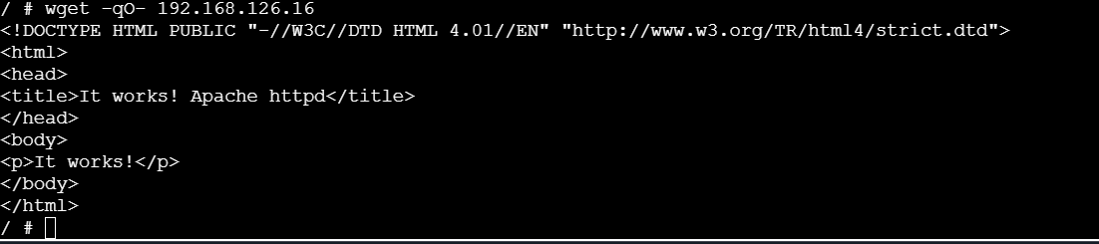

Step 5: Create ClusterIP Service (YAML)
Create file:
vi apache-service.yaml

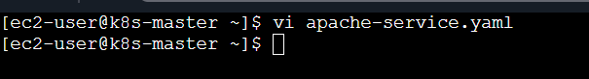
Paste this:
apiVersion: v1
kind: Service
metadata:
name: apache-service
spec:
type: ClusterIP
selector:
app: apache
ports:
- port: 80
targetPort: 80
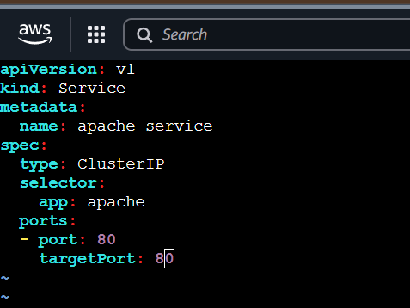

Step 6: Apply Service
kubectl apply -f apache-service.yaml

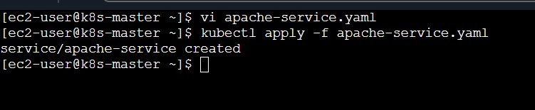
Check:
kubectl get svc

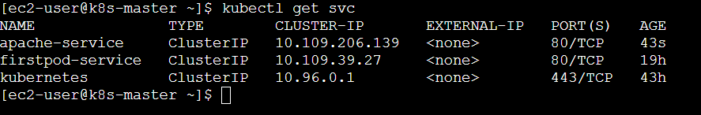
Example output:
NAME TYPE CLUSTER-IP PORT(S)
apache-service ClusterIP 10.96.120.45 80/TCP
Step 7: Test the Service
Since ClusterIP is internal, test like this:

Option 1: Curl inside pod
kubectl exec -it apache-pod -- curl apache-service

Option 2: Create temporary test pod
kubectl run test-pod --image=busybox --restart=Never -it – sh

Inside pod:
wget -qO- apache-service

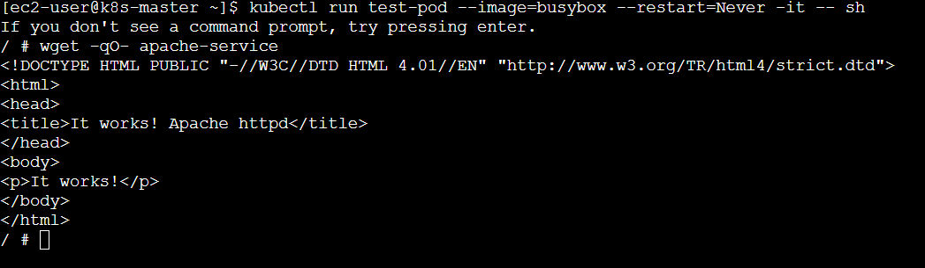

Important Concept
Field |  |  | Meaning
selector |  |  | Matches pod label (app: apache)
port |  |  | Service port
targetPort |  |  | Pod container port
ClusterIP |  |  | Internal IP

Shortcut (Without YAML)
If you're in hurry:
kubectl expose pod apache-pod --type=ClusterIP --port=80 --target-port=80 --name=apache-service

Final Architecture
[Client Pod]
↓
[ClusterIP Service]
↓
[Apache Pod]

2)Expose an Nginx pod externally using a NodePort service.

What You’ll Build
- Nginx Pod
- NodePort Service
- Access from browser (outside cluster)
NodePort = exposes app using NodeIP + Port

Step 1: Create Nginx Pod
kubectl run nginx-pod --image=nginx --restart=Never --port=80

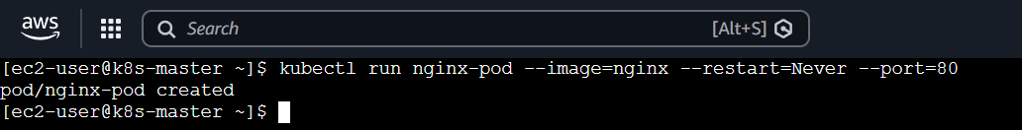
Check:
kubectl get pods -o wide

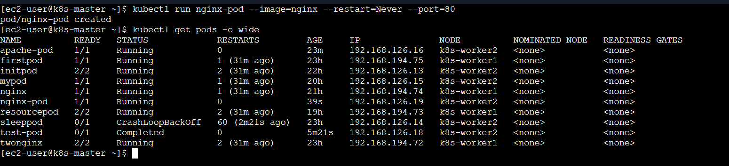
Wait until:
STATUS = Running

Step 2: Expose Using NodePort
kubectl expose pod nginx-pod \
--type=NodePort \
--port=80 \
--target-port=80 \
--name=nginx-service

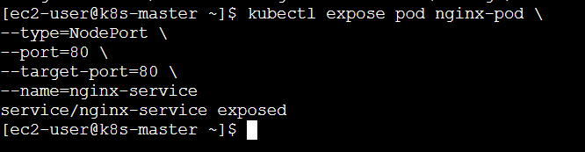

Step 3: Get Service Details
kubectl get svc

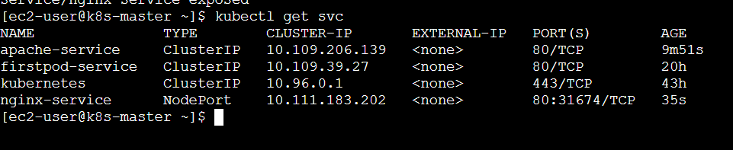
Example output:
NAME TYPE CLUSTER-IP PORT(S)
nginx-service NodePort 10.96.12.34 80:31245/TCP
Important:
- 31245 = NodePort (randomly assigned)

Step 4: Get Node IP
Run:
kubectl get nodes -o wide
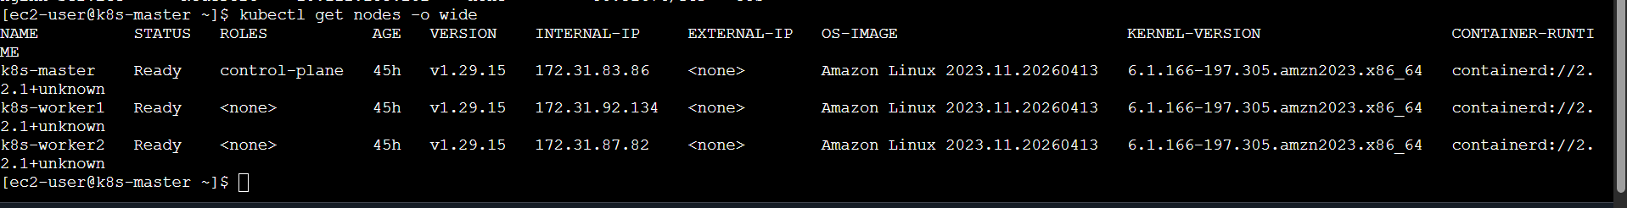
Example:
k8s-worker1 192.168.194.74

Step 5: Access in Browser
Open:
http://<NodeIP>:<NodePort>
Example:
http://54.172.138.146:31674/
You will see Nginx Welcome Page

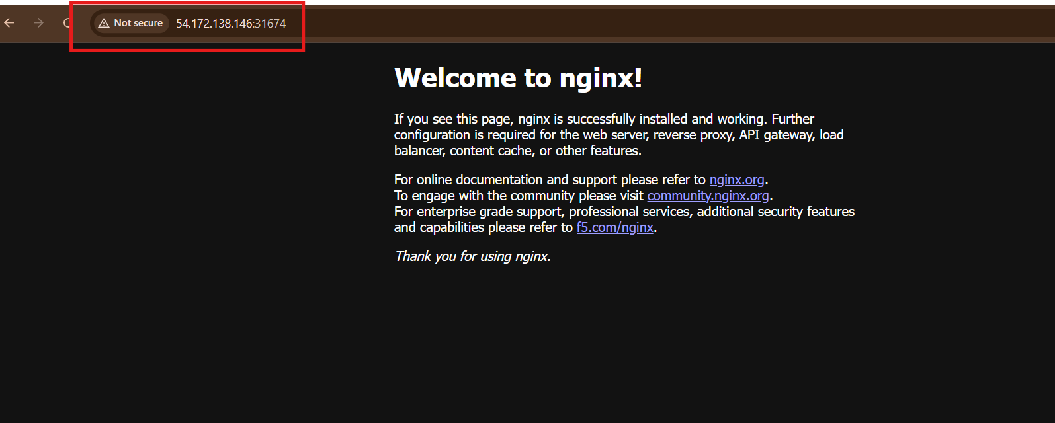

Architecture
Browser
↓
NodeIP:NodePort
↓
NodePort Service
↓
Nginx Pod

3) Deploy a ReplicationController to maintain 3 replicas of an Nginx pod.

What is ReplicationController?
Ensures a fixed number of pods are always running
If 1 pod dies → automatically creates new one
Here: we maintain 3 Nginx pods

Step 1: Create YAML file
vi nginx-rc.yaml

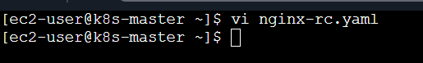
Paste this:
apiVersion: v1
kind: ReplicationController
metadata:
name: nginx-rc
spec:
replicas: 3
selector:
app: nginx
template:
metadata:
labels:
app: nginx
spec:
containers:
- name: nginx-container
image: nginx
ports:
- containerPort: 80
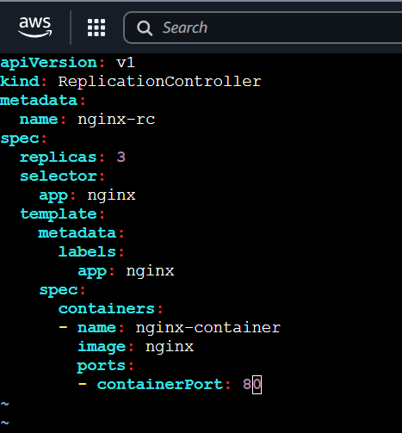

Step 2: Apply the ReplicationController
kubectl apply -f nginx-rc.yaml

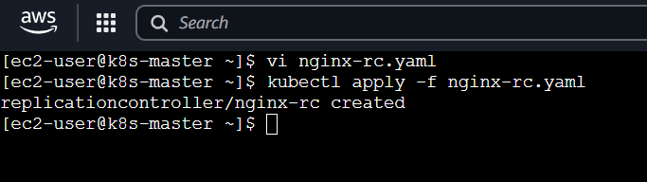

Step 3: Verify
kubectl get rc

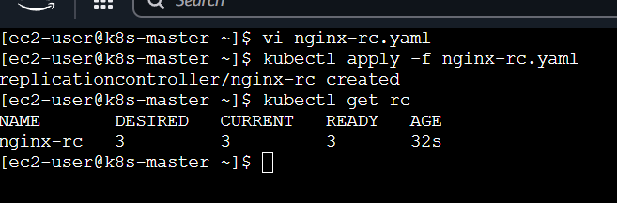
Output:
nginx-rc 3 3 3

Check pods:
kubectl get pods -o wide

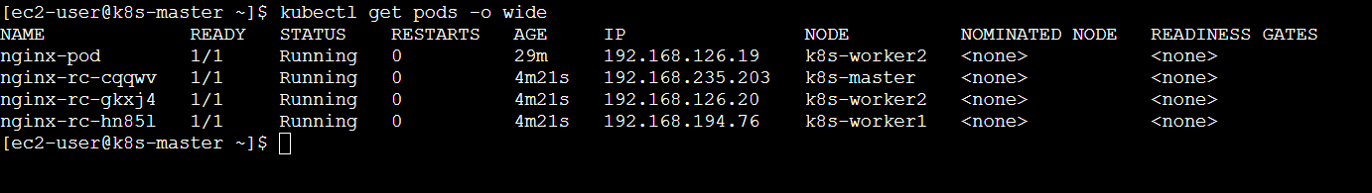
You will see:
nginx-rc-xxxxx Running
nginx-rc-yyyyy Running
nginx-rc-zzzzz Running
Total = 3 pods
Step 4: Test Self-Healing (VERY IMPORTANT)
Delete one pod:
kubectl delete pod <any-nginx-pod-name>
kubectl delete pod nginx-rc-cqqwv

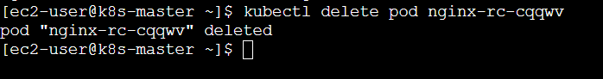
Now check again:
kubectl get pods
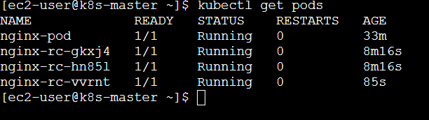
You’ll still see 3 pods
Kubernetes automatically recreated it

(Optional) Expose RC via NodePort
kubectl expose rc nginx-rc --type=NodePort --port=80

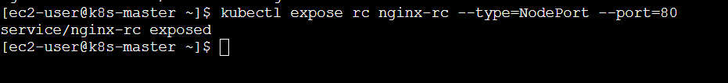
Check:
kubectl get svc

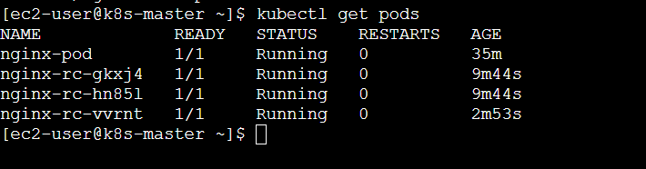

Important Concepts
Field |  | Meaning
replicas: 3 |  | Maintain 3 pods
selector |  | Matches pods with label
template |  | Blueprint for new pods

4) Scale the ReplicationController from 3 replicas to 5 replicas.

Method 1: Command (FASTEST )
Run:
kubectl scale rc nginx-rc --replicas=5

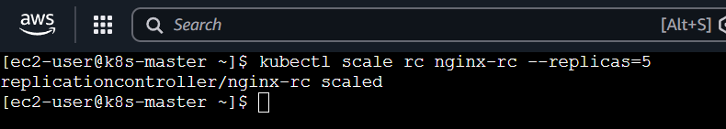

Verify
kubectl get rc

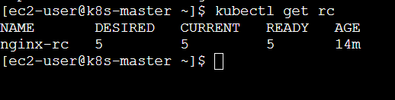
Output should be:
nginx-rc 5 5 5

Check Pods
kubectl get pods -o wide

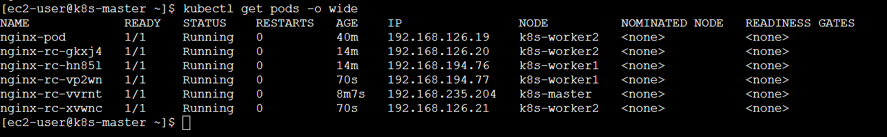
Now you will see 5 pods running:
nginx-rc-xxxxx
nginx-rc-yyyyy
nginx-rc-zzzzz
nginx-rc-aaaaa
nginx-rc-bbbbb
Total = 5 pods
What Just Happened
- RC saw replicas = 5
- It created 2 new pods automatically
- Pods distributed across nodes
Method 2: Edit YAML (Alternative)
kubectl edit rc nginx-rc
Change:
replicas: 3
to:
replicas: 5
Save & exit → pods will scale automatically
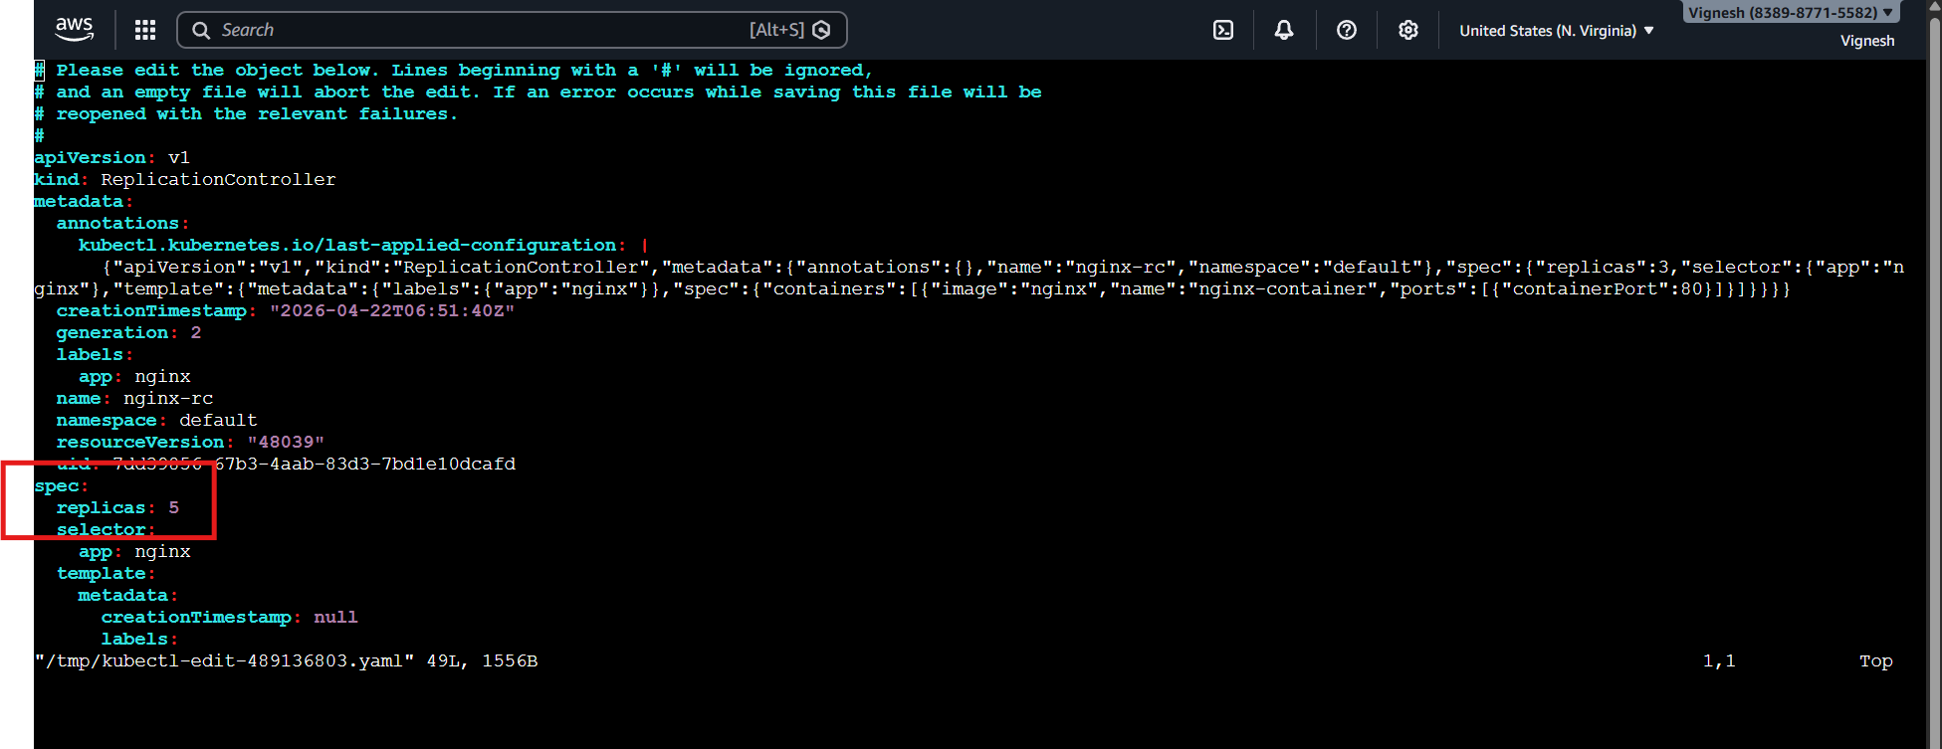

Test Scaling Down (Optional)
Try:
kubectl scale rc nginx-rc --replicas=2
It will delete extra pods automatically

Always check:
kubectl describe rc nginx-rc

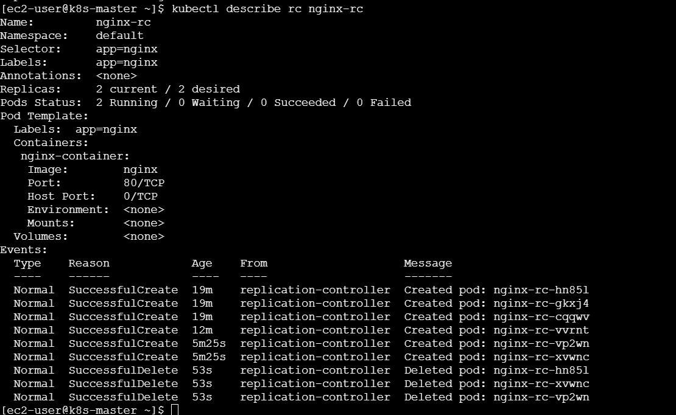

Shows events like:
- Scaling up
- Pod creation

What You Just Learned
- Horizontal scaling ✅
- Auto pod creation ✅
- Load distribution ✅

5) Create a ReplicaSet to manage pods based on multiple labels (prod and test).

Concept
ReplicaSet uses set-based selectors
We’ll use:
matchExpressions
Meaning:
- Select pods where env is either prod OR test
Step 1: Create YAML
vi nginx-rs.yaml
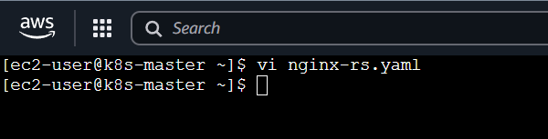
Paste this
apiVersion: apps/v1
kind: ReplicaSet
metadata:
name: nginx-rs
spec:
replicas: 4
selector:
matchExpressions:
- key: env
operator: In
values:
- prod
- test
template:
metadata:
labels:
env: prod
spec:
containers:
- name: nginx-container
image: nginx
ports:
- containerPort: 80
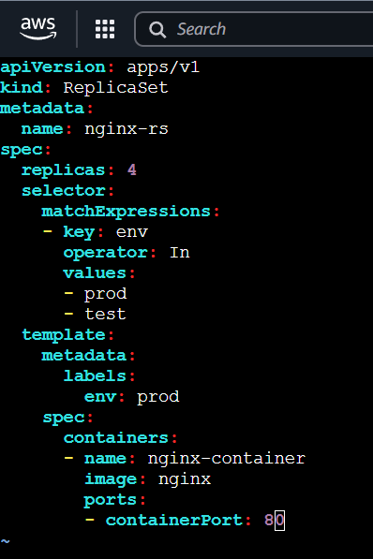

Step 2: Apply
kubectl apply -f nginx-rs.yaml

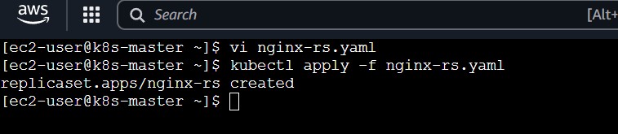

Step 3: Verify
kubectl get rs

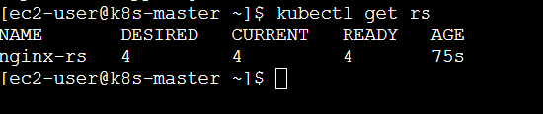

kubectl get pods --show-labels

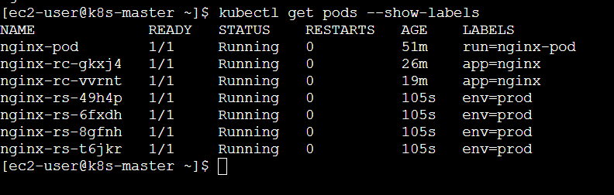
You’ll see:
- 4 pods created
- All having label env=prod

Step 4: Test Multiple Labels
Now manually create a pod with env=test:
kubectl run test-nginx --image=nginx --labels="env=test"

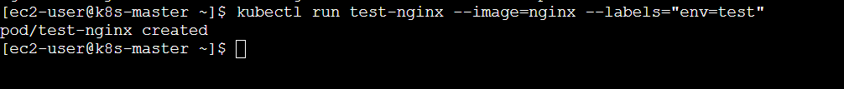

Check again:
kubectl get pods --show-labels

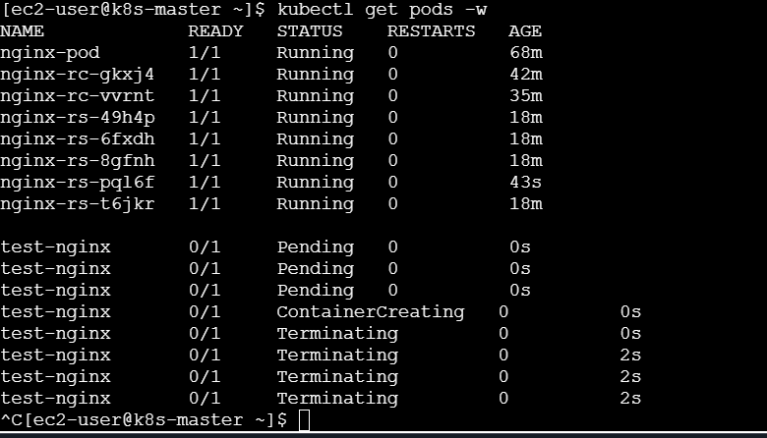
ReplicaSet will now manage:
- env=prod pods (created by RS)
- env=test pod (you created)

Key Learning
Selector Type | Meaning
matchLabels | Exact match
matchExpressions | Advanced (In, NotIn, Exists)

Important Note
ReplicaSet ONLY creates pods from template
But it can adopt existing pods if labels match.

Bonus: Try Changing Label
kubectl label pod test-nginx env=dev --overwrite
Now RS will:
- See pod not matching ❌
- Create a new one to maintain replicas ✅

What You Just Learned
- Multi-label selection ✅
- Set-based selectors ✅
- Pod adoption behavior ✅

6) Deploy a ReplicaSet that excludes pods with the label backend.

Goal
Create a ReplicaSet that:
- Manages pods
- ❌ Excludes pods with label backend
Key Concept
We use:
operator: NotIn
Meaning:
Select pods where label ≠ backend

Step 1: Create YAML
vi nginx-rs-exclude.yaml
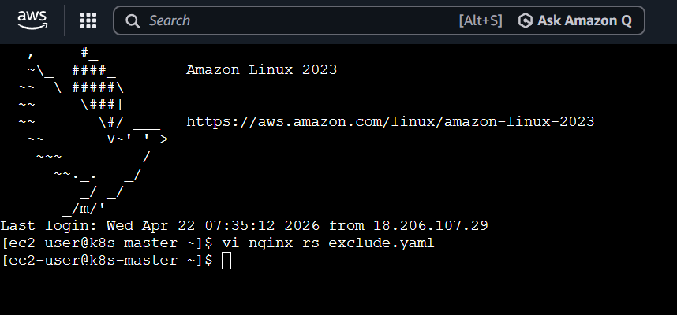
Paste this :
apiVersion: apps/v1
kind: ReplicaSet
metadata:
name: nginx-rs-exclude
spec:
replicas: 3
selector:
matchExpressions:
- key: tier
operator: NotIn
values:
- backend
template:
metadata:
labels:
tier: frontend
spec:
containers:
- name: nginx-container
image: nginx
ports:
- containerPort: 80
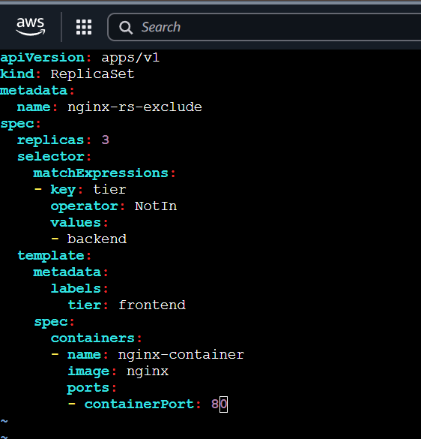

Step 2: Apply
kubectl apply -f nginx-rs-exclude.yaml

Step 3: Verify
kubectl get pods --show-labels

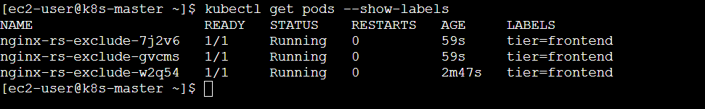
You’ll see:
nginx-rs-exclude-xxxx tier=frontend ✅
nginx-rs-exclude-yyyy tier=frontend ✅
nginx-rs-exclude-zzzz tier=frontend ✅

Step 4: Test Exclusion
Create backend pod
kubectl run backend-pod --image=nginx --labels="tier=backend"

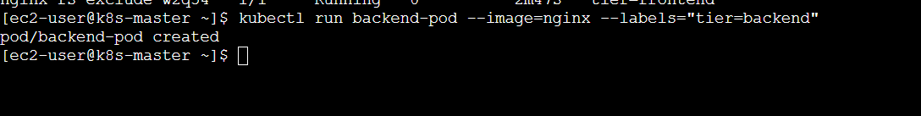

Check again
kubectl get pods --show-labels

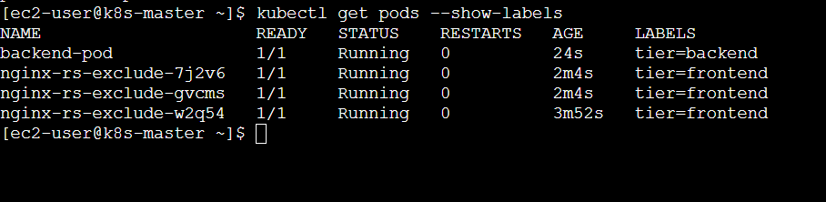
Result:
- backend-pod → ❌ NOT controlled by ReplicaSet
- RS pods → still 3 ✅
Because:
tier=backend → excluded

Key Understanding
Label |  |  |  | Managed by RS?
tier=frontend |  |  |  | ✅ YES
tier=backend |  |  |  | ❌ NO

Bonus (Deep Understanding)
If you change label:
kubectl label pod backend-pod tier=frontend –overwrite

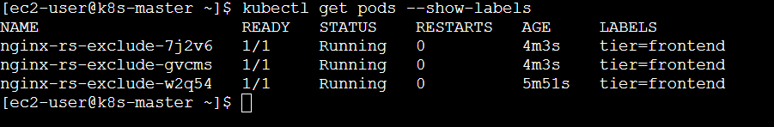

Now ReplicaSet will:
- adopt this pod
- may delete/create to maintain count

One-Line Concept
NotIn → exclude matching labels from ReplicaSet control

7) Test load balancing across multiple pods using a NodePort service.

Step 0: Clean (Recommended)
kubectl delete all --all
Fresh environment = no confusion

Step 1: Create ReplicaSet (3 Pods)
vi nginx-rs.yaml
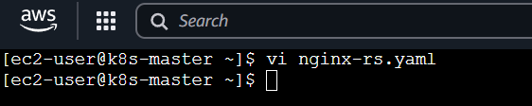
Paste:
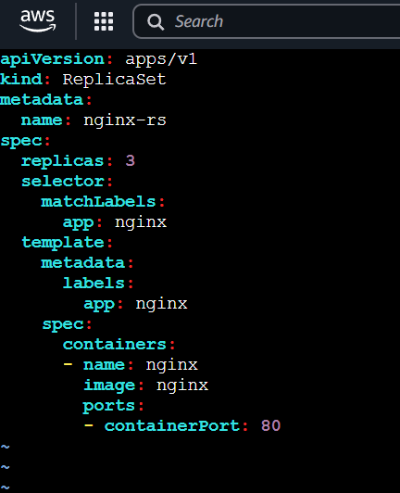
apiVersion: apps/v1
kind: ReplicaSet
metadata:
name: nginx-rs
spec:
replicas: 3
selector:
matchLabels:
app: nginx
template:
metadata:
labels:
app: nginx
spec:
containers:
- name: nginx
image: nginx
ports:
- containerPort: 80

Apply
kubectl apply -f nginx-rs.yaml
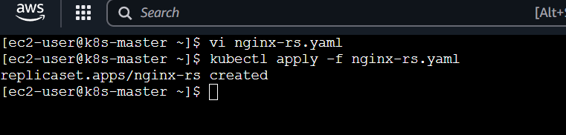

Verify
kubectl get pods -o wide
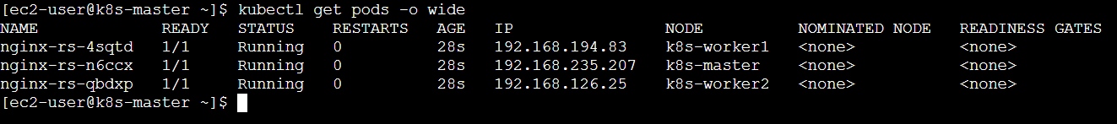
You should see 3 pods

Step 2: Create NodePort Service
vi nginx-service.yaml
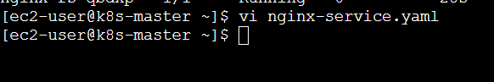

Paste:
apiVersion: v1
kind: Service
metadata:
name: nginx-service
spec:
type: NodePort
selector:
app: nginx
ports:
- port: 80
targetPort: 80
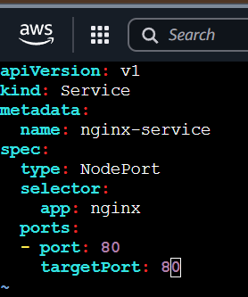

Apply
kubectl apply -f nginx-service.yaml

Get Port
kubectl get svc

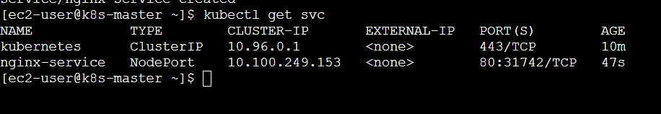
Example:
nginx-service NodePort 80:31245/TCP
NodePort = 31245

Step 3: Get Public IP
From AWS EC2:
Copy Public IPv4

Step 4: Open in Browser
http://<PUBLIC-IP>:31245
http://54.172.138.146:31742/
You’ll see Nginx page
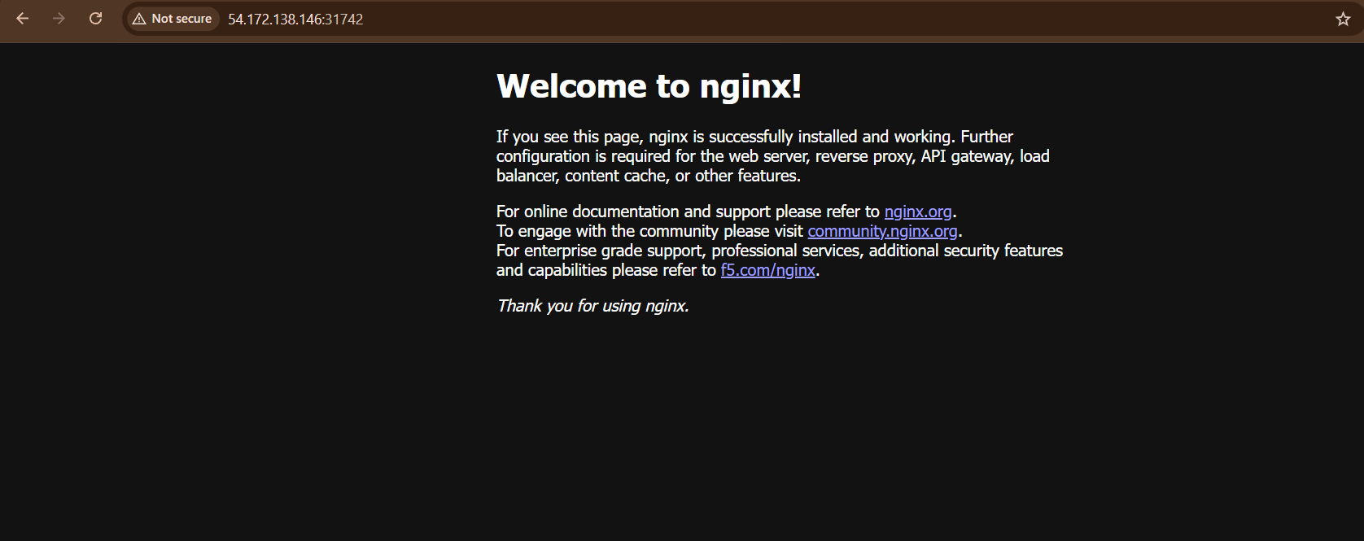

Step 5: Modify Each Pod
We’ll make each pod show its name.
Get pod names:
kubectl get pods

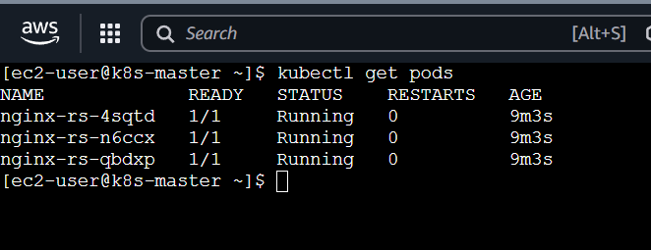

For each pod:
kubectl exec -it <pod-name> -- sh
kubectl exec -it nginx-rs-4sqtd – sh
Inside:
echo "<h1>Pod: $(hostname)</h1>" > /usr/share/nginx/html/index.html
exit
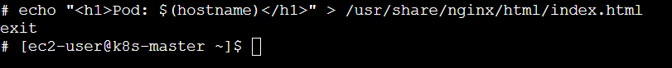
Do this for all 3 pods
Pod 1
kubectl exec -it nginx-rs-4sqtd -- sh
Then inside:
echo "<h1>Pod 1</h1>" > /usr/share/nginx/html/index.html
exit
Pod 2
kubectl exec -it nginx-rs-n6ccx -- sh
echo "<h1>Pod 2</h1>" > /usr/share/nginx/html/index.html
exit
Pod 3
kubectl exec -it nginx-rs-qbdxp -- sh
echo "<h1>Pod 3</h1>" > /usr/share/nginx/html/index.html
exit

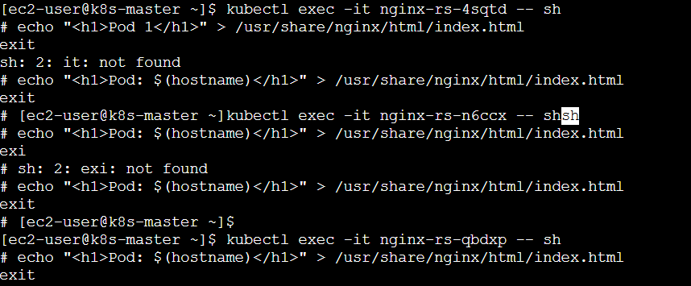

Step 6: Test Load Balancing
Method 1: Curl loop
for i in {1..10}; do curl http://<PUBLIC-IP>:31245; done

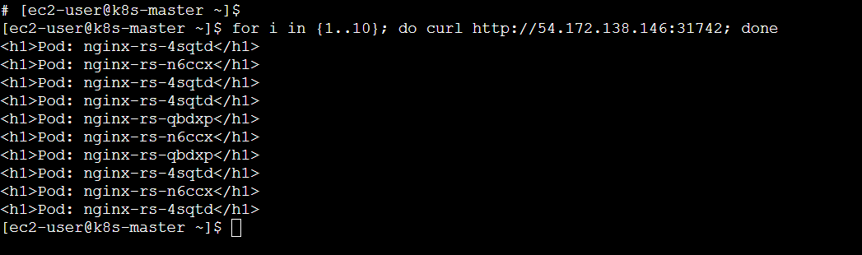

Method 2: Browser refresh
Refresh multiple times

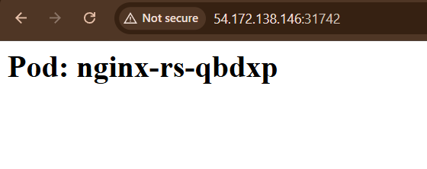

Expected Output
<h1>Pod: nginx-rs-abc</h1>
<h1>Pod: nginx-rs-xyz</h1>
<h1>Pod: nginx-rs-pqr</h1>
Each request hits different pod
How It Works
Client → NodeIP:NodePort → Service → Random Pod
Kubernetes load balances automatically
Debug Tips (If Not Working)
1. Check endpoints
kubectl get endpoints nginx-service
2. Check pods
kubectl get pods
3. AWS Security Group
Allow:
30000–32767
Final Result
- 3 pods running
- Service exposed
- Traffic distributed

8)Delete a ReplicationController without affecting the running pods.

Goal
Delete ReplicationController (RC)
❌ Do NOT delete its pods

Default Behavior
If you run:
kubectl delete rc nginx-rc
It will:
- ❌ Delete RC
- ❌ Delete ALL pods managed by it

Correct Command (KEEP pods)
Use:
kubectl delete rc nginx-rc --cascade=orphan

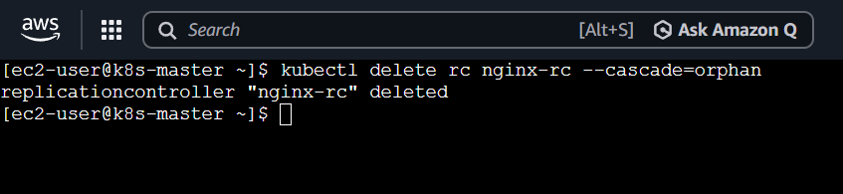

What this does
Delete RC → Keep pods alive (orphaned)
Pods will continue running independently

Verify
kubectl get pods
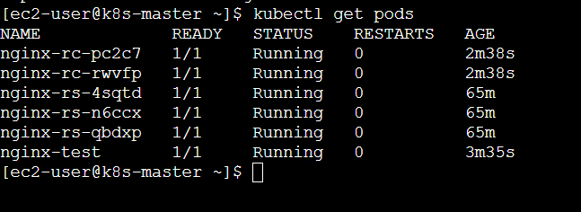
You’ll still see:
nginx-rc-xxxxx Running ✅

Check ownership removed
kubectl get pod <pod-name> -o yaml | grep ownerReferences -A 5
kubectl get pod nginx-rc-pc2c7 -o yaml | grep ownerReferences -A 5

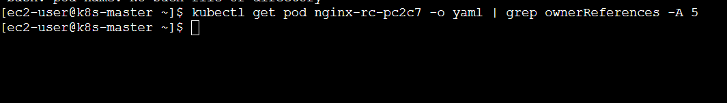
You’ll see:
ownerReferences: null
Means pods are now independent

Bonus Test
Delete one pod:
kubectl delete pod <pod-name>

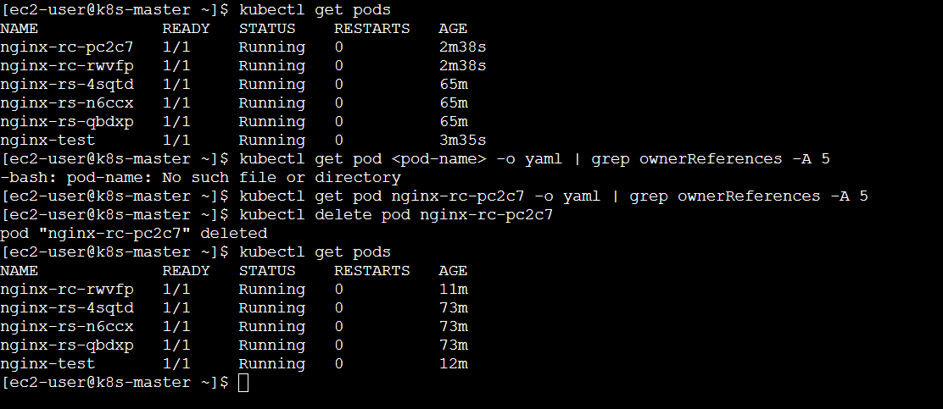
Now:
- ❌ It will NOT be recreated
- Because RC is gone

Key Concept
Action | Result
delete rc | deletes pods ❌
delete rc --cascade=orphan | keeps pods ✅

Modern Equivalent (Important)
Same works for:
kubectl delete rs <name> --cascade=orphan

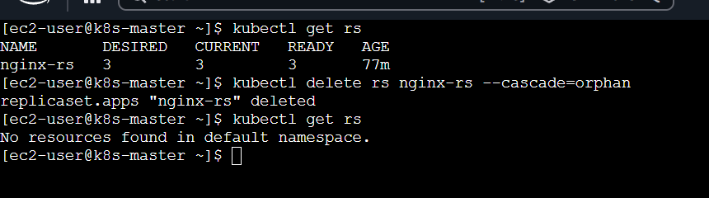

kubectl delete deployment <name> --cascade=orphan

One-Line Answer
Use --cascade=orphan to delete RC without deleting pods

What You Learned
- Controller ownership ✅
- Orphaning pods ✅
- Safe deletion ✅

Concepts

🔹 You can delete:
- RC → kubectl delete rc
- RS → kubectl delete rs
- Pod → kubectl delete pod

